For this assignment, you will do two things:

- Maintain a food diary for three days using MyFitnessPal using this website: https://www.myfitnesspal.com/

The username is: ritagabrielyan@yahoo.com
The password is: Student123

- Write a nutritional self-assessment paper. In your paper, you will analyze your eating habits, food patterns, and nutrition intake.

Maintaining your diary:
You will use the MyFitnessPal food diary app to record everything that goes into your digestive system over the course of three days. Record everything you eat and drink. I usually eat healthy and exercise at least twice a week, so include that in there.
It is preferable to record your food intake for at least one non-school day or one non-weekday (for example, you should do: Wednesday, Thursday and Friday). This way, you will see how your eating habits change with your schedule.
It is important that you take time each day to record your food, drink, and drug intake rather than relying on your memory. An honest, detailed diary will help you gain a better understanding of yourself personally and professionally.
Take screenshots of your MyFitnessPal food diary to include in your analysis paper. At the end of the three days, print the final report in MyFitnessPal to include with your written paper.

Follow these instructions:
Record everything that goes into your digestive system over the course of three days. Record everything you eat and drink, and record the name and dosage of any medications that you take including vitamins, minerals, and herbal supplements.
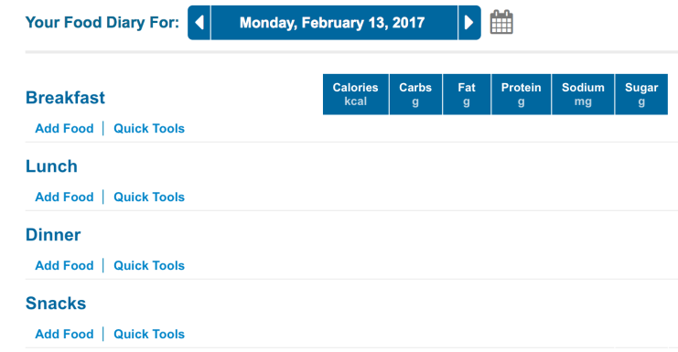
Record your activity and moods in the Notes section for each day. Remember to SAVE every time you edit; otherwise, your notes will be lost.
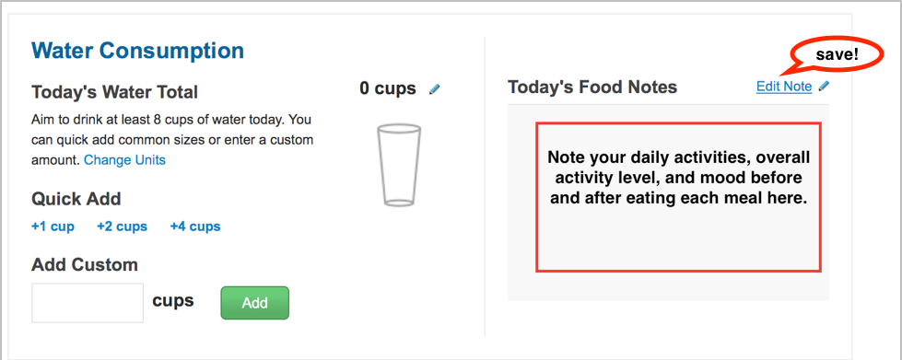
Daily Reports
You will need to access MyFitnessPal reports for your written paper. Use this spreadsheet to track your daily nutrient intake.
Go to Reports.
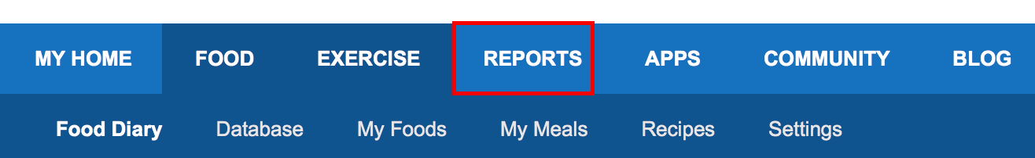

Choose a Report: Use the drop-down menu to select a report for each of the nutrients listed.
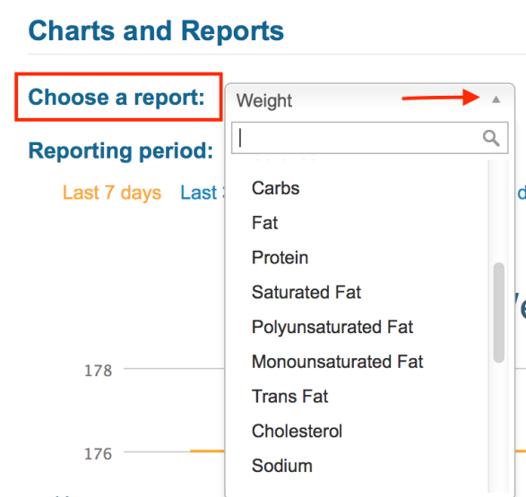
Record the recommended intake and your actual intake of each nutrient for each day.
  - Hover your mouse over the red line to get the recommended daily goal percentage.
  - The blue bar indicates your actual intake percentage.
  - Put these numbers on the spreadsheet.
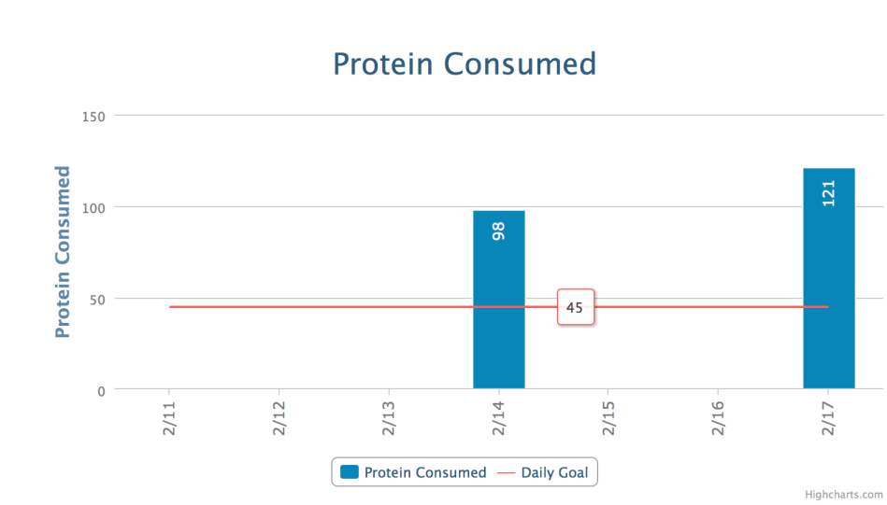
Complete the spreadsheet for each day and each nutrient.
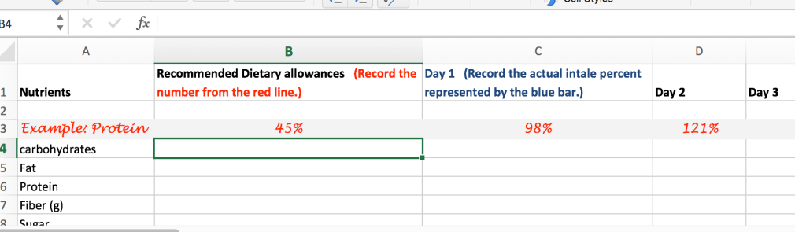

- Save and upload your completed spreadsheet with your written anlaysis paper.
- Take screenshots of your food diary to include in your analysis paper.
- At the end of the three days, print the final report in MyFitnessPal to include with your written assignment.
Use the file attached that is titled “USE FOR nutrient spread sheet”. Record data in there.
See the file attached that is titled “NUTRITION PART 1” and “NUTRITION PART 2” for the self-assessment portion. This is for the written portion. Read and answer it carefully please.
PLEASE SEE ATTACHMENT TITLED “SAMPLE PAPER”. THE FINAL OUTCOME SHOULD LOOK LIKE THAT. GO WITH THE RUBRIC THAT IS ATTACHED FOR FULL CREDIT.
- The paper should be 5–8 pages in length including the screenshots.
- Attach a copy of the final report from MyFitnessPal along with your completed nutrient spreadsheet with your paper.
- Use APA and include a title and reference page.
- PLAGIARISM FREE PAPER
- PLEASE MAKE USE OF ALL THE ATTACHMENTS. MAKE SURE ALL SCREENSHOTS ARE DONE. I NEED THE EXCEL SPREADSHEET, THE WRITTEN PORTION, THE MYFITNESSPAL DIARY SCREENSHOTS, AND EVERYTHING ELSE TO LOOK LIKE THE SAMPLE PAPER THAT IS PROVIDED.

